

NEW YEAR’S EVE
HAPPY HOLIDAYS
MERRY CHRISTMAS
“This institution is an equal opportunity provider.”

AVAILABLE AT BREAKFAST AND LUNCH DAILY: FRESH FRUIT, JUICE, AND MILK.
*MENU IS SUBJECT TO CHANGE*

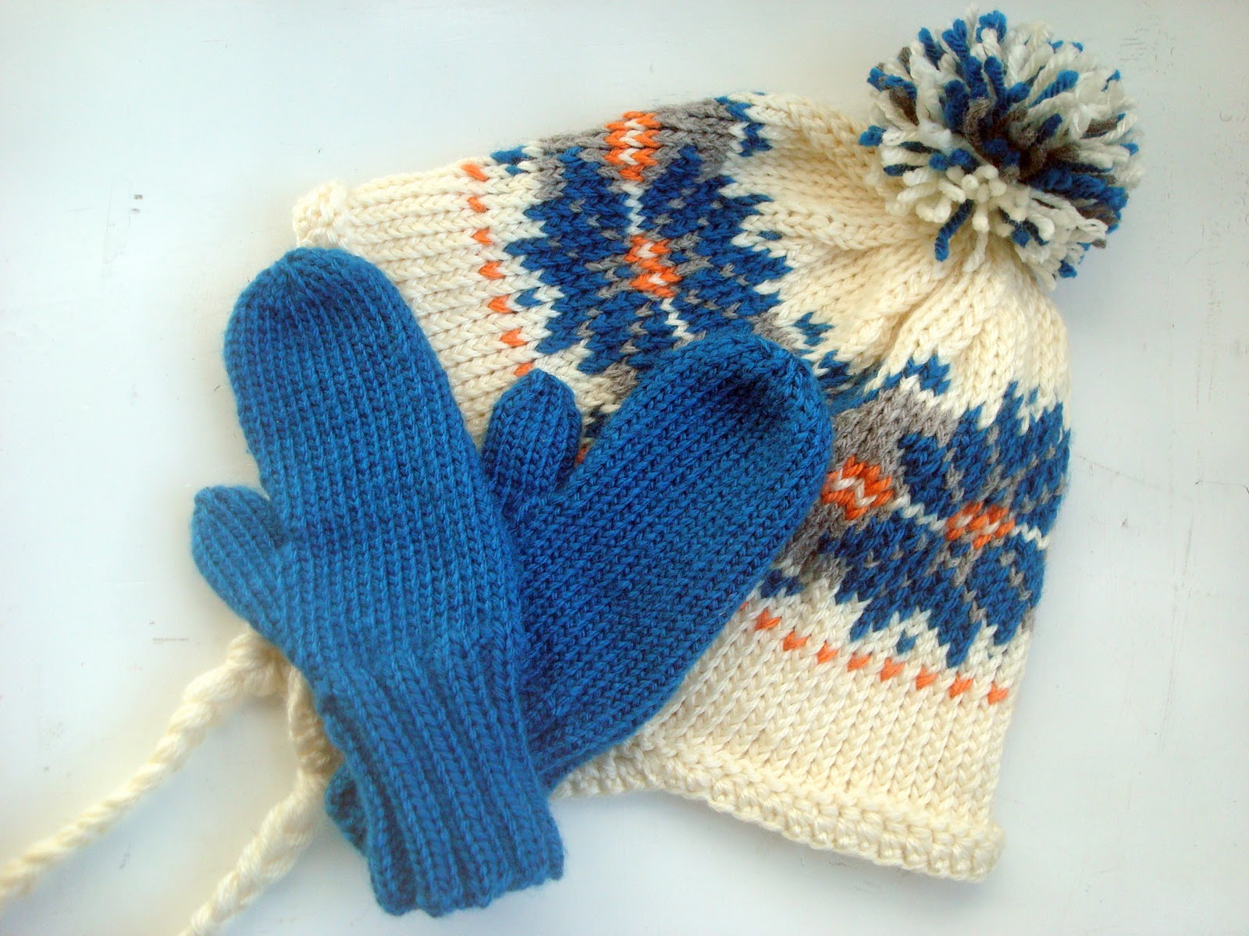

FRENCH TOAST STICKS
HAM
MUFFIN
YOGURT
FRUIT JUICE
FRUIT
MILK

BREAKFAST BURRITOS
CINNAMON ROLLS
FRUIT JUICE
FRUIT
MILK
SAUSAGE BISCUIT
CEREAL
POP-TARTS
FRUIT JUICE
FRUIT
MILK
PANCAKES
LINK SAUSAGE
MUFFINS
YOGURT
FRUIT
MILK
DECEMBER 2025
KEMPER COUNTY MIDDLE/HIGH SCHOOL
MINI CINNAMONS
POP-TARTS
BAGEL W/CREAM CHEESE
FRUIT JUICE
FRUIT
MILK
CHEESE OMELET
CEREAL
TOAST
GRITS
FRUIT JUICE
FRUIT
MILK
SAUSAGE BISCUIT
POP-TARTS
CEREAL
FRUIT JUICE
FRUIT
MILK

WAFFLES
CHICKEN TENDERS
CEREAL
FRUIT JUICE
FRUIT
MILK

Manager’s Choice
WAFFLES
CHICKEN PATTIE
APPLE FRUDEL
FRUIT JUICE
FRUIT
MILK
SAUSAGE BISCUIT
POP-TARTS
CEREAL
FRUIT JUICE
FRUIT
MILK
GRITS
OMELET
TOAST
LINK SAUSAGE
FRUIT JUICE
FRUIT
MILK

Manager’s Choice
MUFFINS
YOGURT
CEREAL
POP-TARTS
FRUIT
MILK
SAUSAGE BISCUIT
CEREAL
FRUIT JUICE
FRUIT
MILK




